Dear Friend:

On behalf of the Massachusetts Alliance of Boys & Girls Clubs and our 42 member Clubs serving over 168,000 children in Massachusetts, we ask that you please support **our $2million FY2019 budget request for earmarked funds in the Youth-At-Risk Grant line item (#4590-1507).**

We would like to start by thanking you for your continued support of the Boys & Girls Clubs’ mission. Our Clubs received an allocation of $1.6 million in the FY18 Youth-at-Risk line item, which once received will help serve children at 82 Club sites across the state.

If you are looking to make the best possible use of public funds, the Massachusetts Alliance of Boys & Girls Clubs should be a top choice: **targeted programming, a return on state investment, and data-driven decision making.** The Club experience and programming are focused on community priorities like preventing substance use, boosting academic performance, discouraging risky behaviors, and increasing civic engagement. We have just completed the first full year of our Outcomes Performance Project, which tracks the outcomes of our young members and makes apples-to-apples comparisons to community and statewide averages. The ability to measure and track outcomes as part of a sophisticated data collection effort sets the Massachusetts Alliance of Boys & Girls Clubs apart from other youth serving organizations, and it helps us clearly demonstrate our impact on kids and communities. Among Clubs surveyed, findings show that Club membership correlates with a meaningful decrease in risky and dangerous behaviors among teens. For example:

* **89% of Club teens abstain from alcohol**, compared with only 66% of the general Massachusetts teen population
* **89% of Club teens abstain from marijuana use**, compared with 75% of the Massachusetts teen population
* **98% of Club teens abstain from cigarette smoking**, compared to 92% of the Massachusetts teen population

We are grateful for the funding we have received each year from the Commonwealth over the past decade, and we pride ourselves on our reputation as responsible stewards of public money. We would like to point out that funding for the Alliance still lags dramatically behind its pre-recession high of $3.3 million, while demand for Boys & Girls Club services continues to grow. We also note that the Governor’s budget would allocate only $500,000 for this entire line item, an unfortunate decrease from last year’s final line item funding of $3.76 million. Failing to fully fund this line item would be a mistake. We are asking you, our allies in the House, to rectify this situation by fully funding the line item and increasing the Alliance’s earmark.

As a final note, **it is critically important to have any budget language refer specifically to the *Massachusetts Alliance of Boys & Girls Clubs***. The Alliance was established nearly a decade ago to serve as the single access point for state funding for Boys & Girls Clubs across Massachusetts and, in so doing, avoid pitting Club against Club as they applied for government money. Since

that time, the legislature has eliminated the practice of specifically earmarking money for individual Boys & Girls Clubs. Both the Clubs and the Commonwealth have greatly benefited as a result. Failing to specifically reference the Massachusetts Alliance of Boys & Girls Clubs would reverse an entire decade's worth of progress on this issue.

Along with our board of directors, Club staff, and the over 168,000 youth we serve, we would like to extend our gratitude for the House’s continued support. If you have any questions, please feel free to call Dennis Murphy or Anthony Abdelahad at 617-423-0028.

Sincerely,

 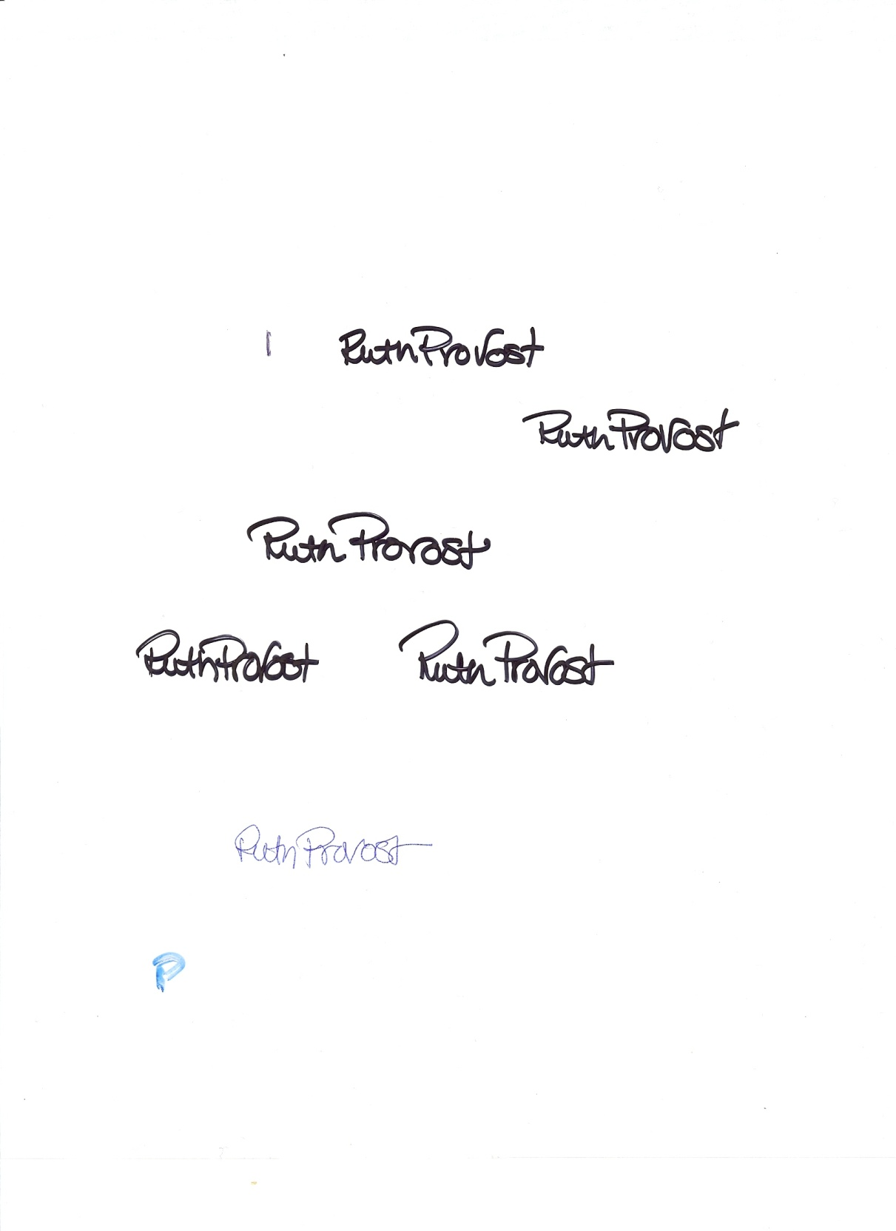

**Dennis Murphy Ruth Provost**

Ventry Associates President, MA Alliance of Boys & Girls Clubs